Create And Configure IBM Cloud Service Create A Database in Cloudant DB

To create a database in Cloudant DB to store location data

# STEPS

1. Login to IBM Cloud with smart internz mail ID and Password.

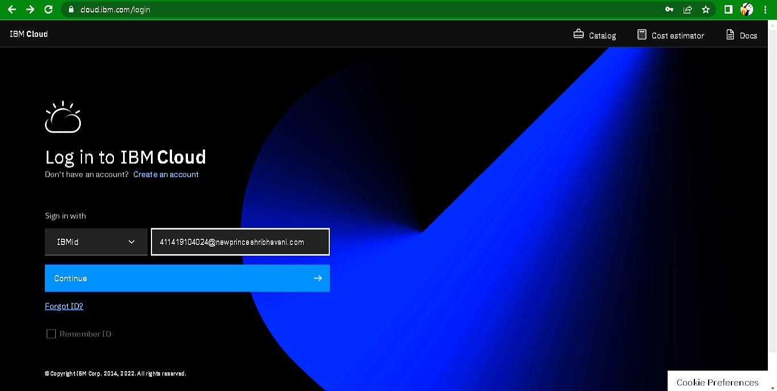

1. 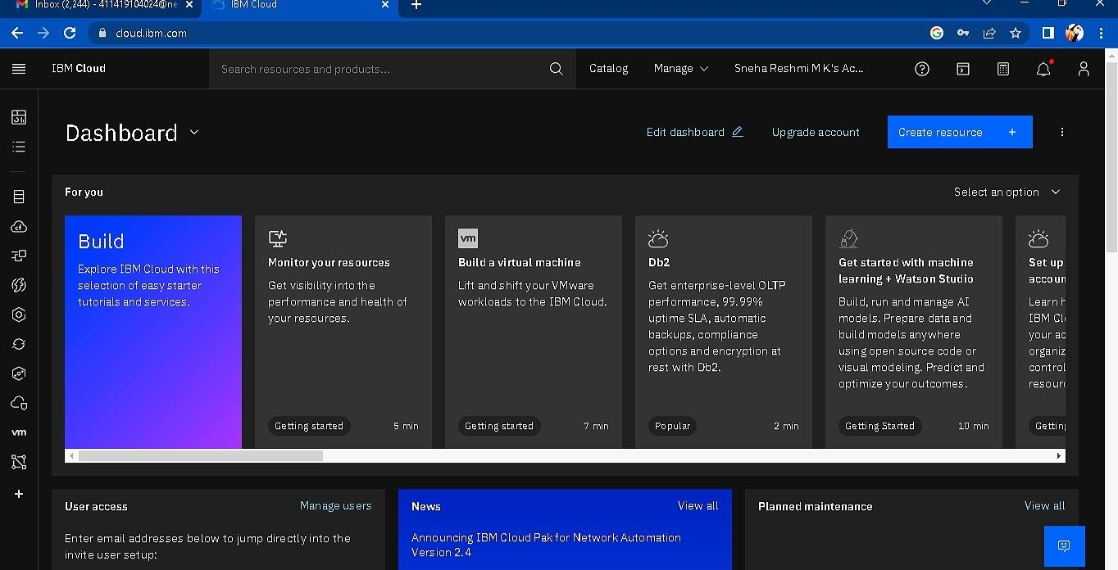Click “Create Resource +” button
2. 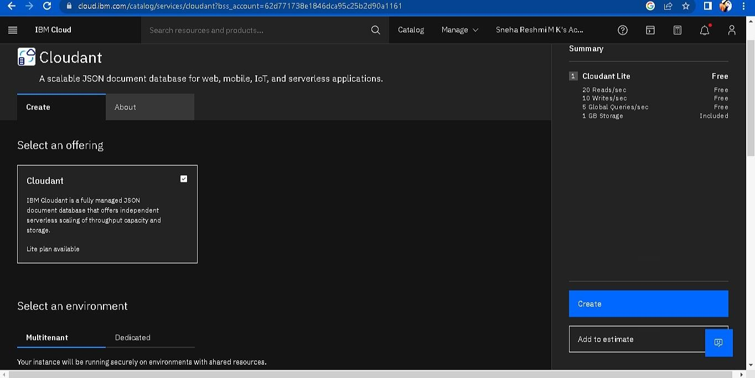Search Cloudant in Catalog then Choose the Lite version

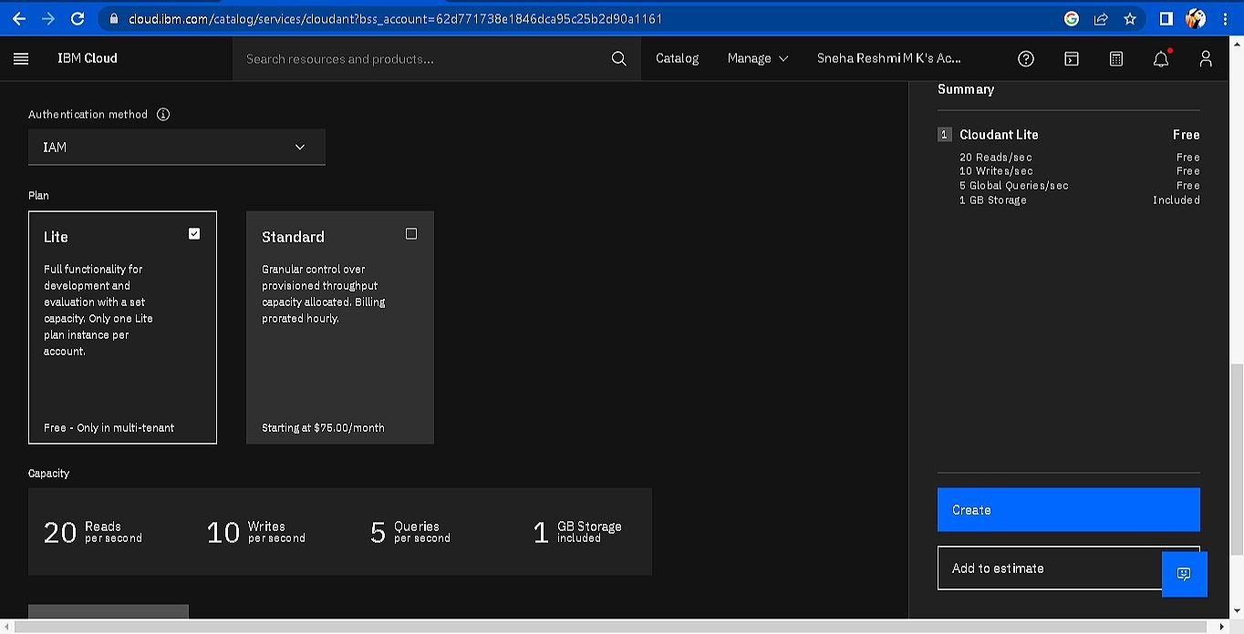

1. 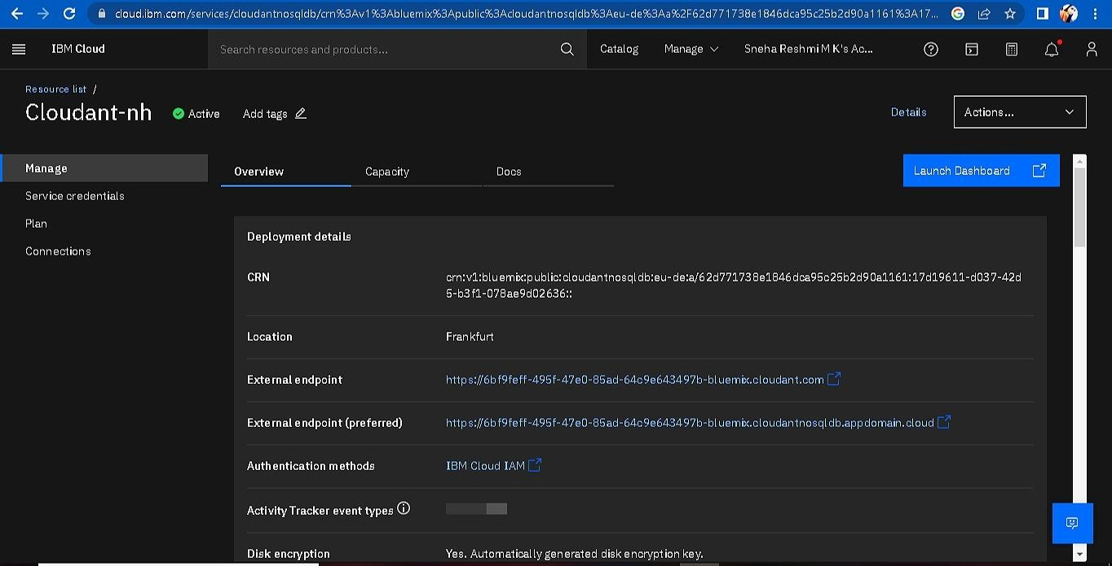The Cloudant database resource created
2. click on launch dashboard

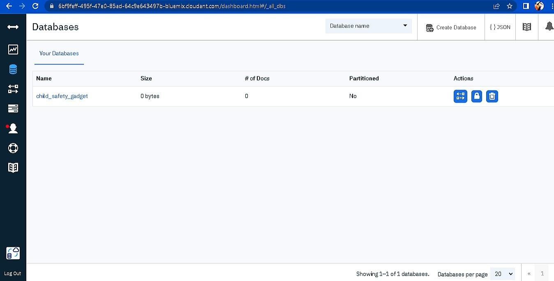

1. Click “Create Database”. Entered “child_safety_device” as the database name and the “Non-partitioned” option.
2. The database “child_safety_device” has been created and it's work Successfully

# RESULT:

A database to store the location data on Cloudant DataBase has been c